**Hiring Process Analytics**

**Project Description:**

**The hiring process is a crucial function of any company, and understanding trends such as the number of rejections, interviews, job types, and vacancies can provide valuable insights for the hiring department. My project involves analysing the company's hiring process data to draw meaningful insights and help improve the overall efficiency of the hiring department.**

**As a data analyst, I will work with a dataset containing records of previous hires. This project aims to analyse this data and answer key questions that can help the company refine its hiring strategies. Through this analysis, I aim to identify trends and patterns that can inform decision-making and enhance the company's recruitment efforts.**

**Approach:**

**1. Data Collection and Review:**

**- Acquired and reviewed the dataset to understand key columns such as gender, salary, department, and position tier.**

**2. Data Cleaning:**

**- Used Excel functions to identify and handle missing values.**

**- Applied statistical measures to detect and treat outliers.**

**3. Data Transformation:**

**- Combined categories in certain columns to simplify analysis.**

**4. Analysis:**

**- Gender Distribution: Used `COUNTIF` functions to determine the gender distribution of hires.**

**- Average Salary: Calculated average salary using the `AVERAGE` function.**

**- Salary Distribution: Created class intervals to understand salary ranges.**

**5. Visualization:**

**- Used pie charts and bar graphs to visualize department proportions and position tiers.**

**Tools Used**

**- Excel Functions: ’IF’, ‘ISBLANK’, ‘COUNTIF’, ‘AVERAGE’**

**-Charts and Graphs: Pie charts, and bar graphs for data visualization**

**Tech-Stack Used:**

**I used Microsoft Excel 2019 to make this project. I also made use of the formulas in the tool.**

**Insights:**

**Task A: Hiring Analysis**

**The hiring process involves bringing new individuals into the organization for various roles. Here the gender distribution of hires is being determined.**

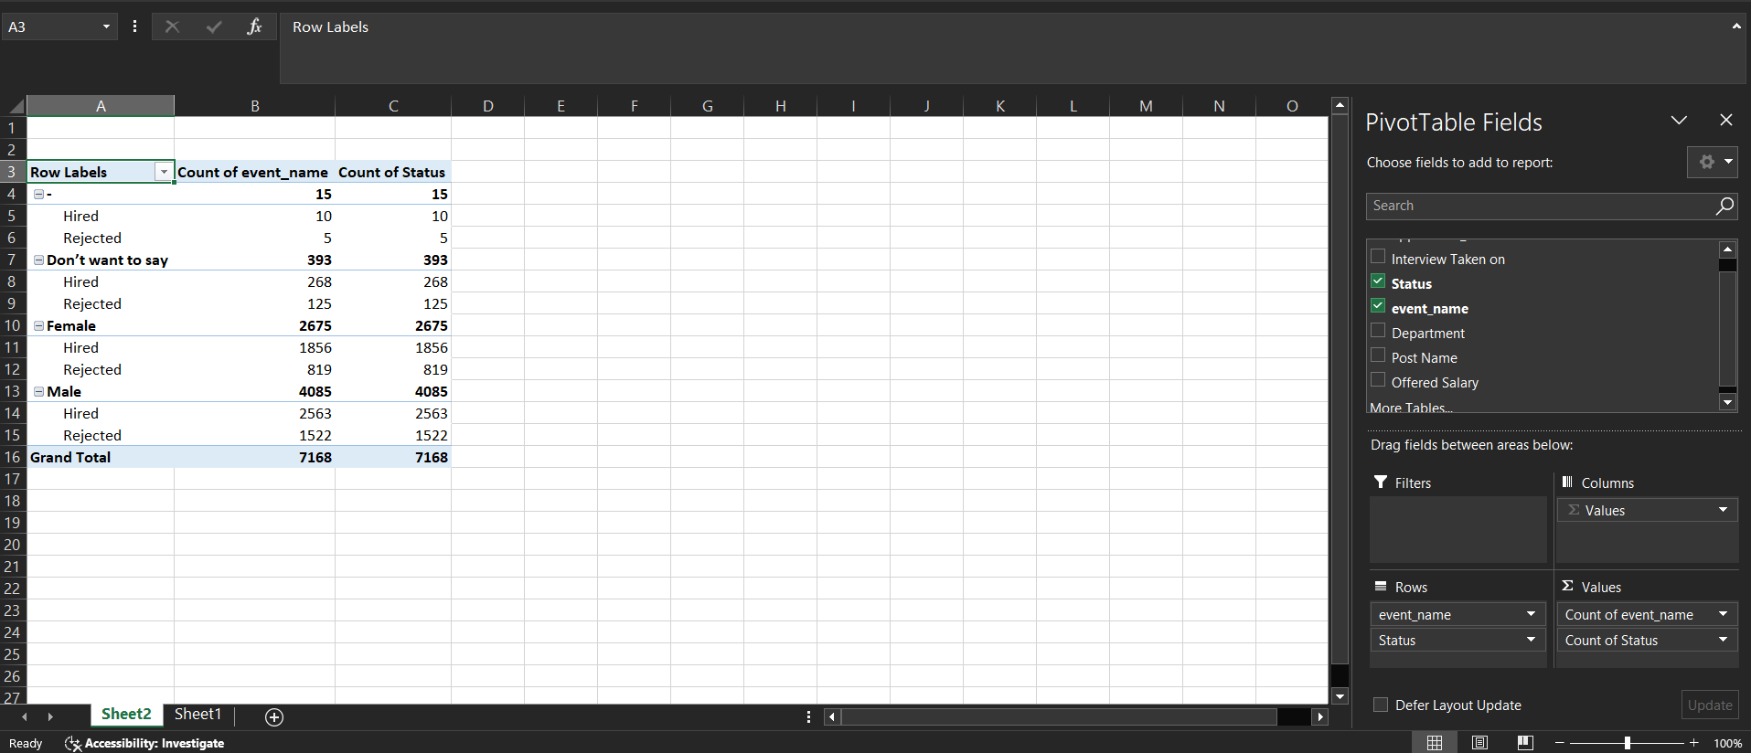

**I formed a Pivot Table and then dragged the event_name and status in Rows and Values column. This gives a clear picture of how many males, females are hired or rejected along with others. I also got a total of males and females involved.**

**Task B: Salary Analysis**

**The average salary is calculated by adding up the salaries of a group of employees and then dividing the total by the number of employees. Using the Excel functions the average salary offered by this company is being calculated.**

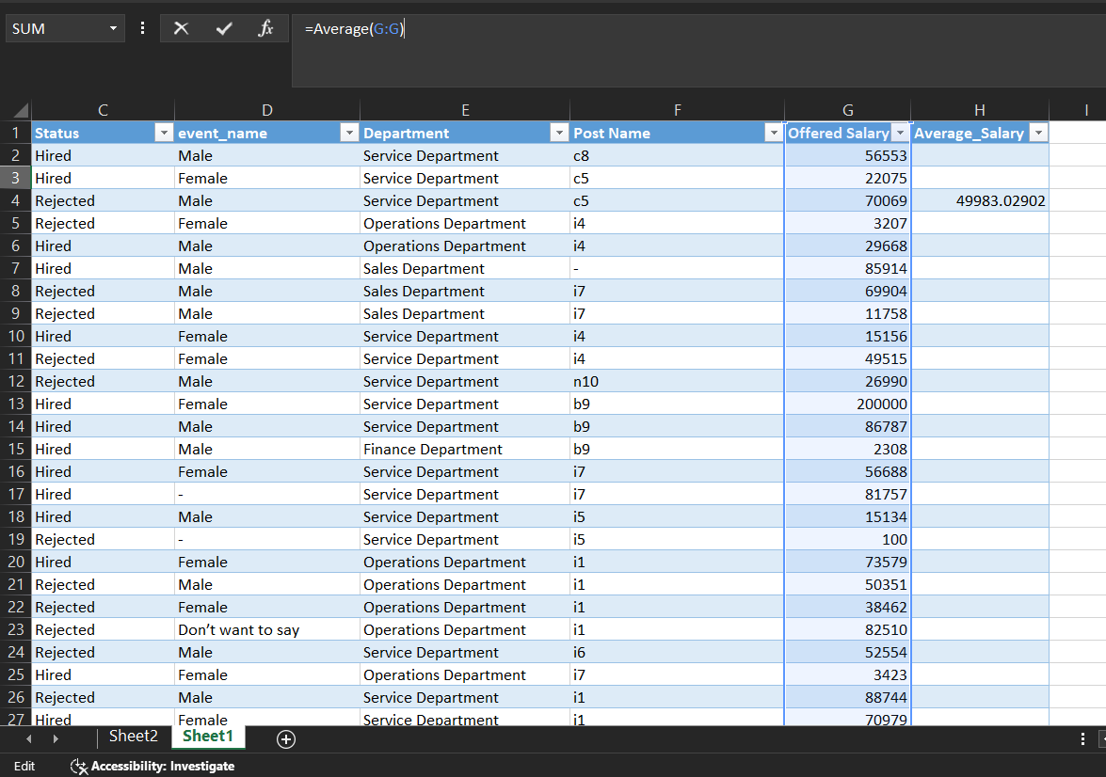

**Here, after making appropriate table, I selected an empty cell where I will display the result. Thereafter, I used the formula of the AVERAGE for the column Offered Salary. In this, the average salary came out to be Rs. 49978.1486.**

**Task C: Salary Distribution**

**Class intervals represent ranges of values, in this case, salary ranges. The class interval is the difference between the upper and lower limits of a class. Create class intervals for the salaries in the company. This helped in understanding the salary distribution.**

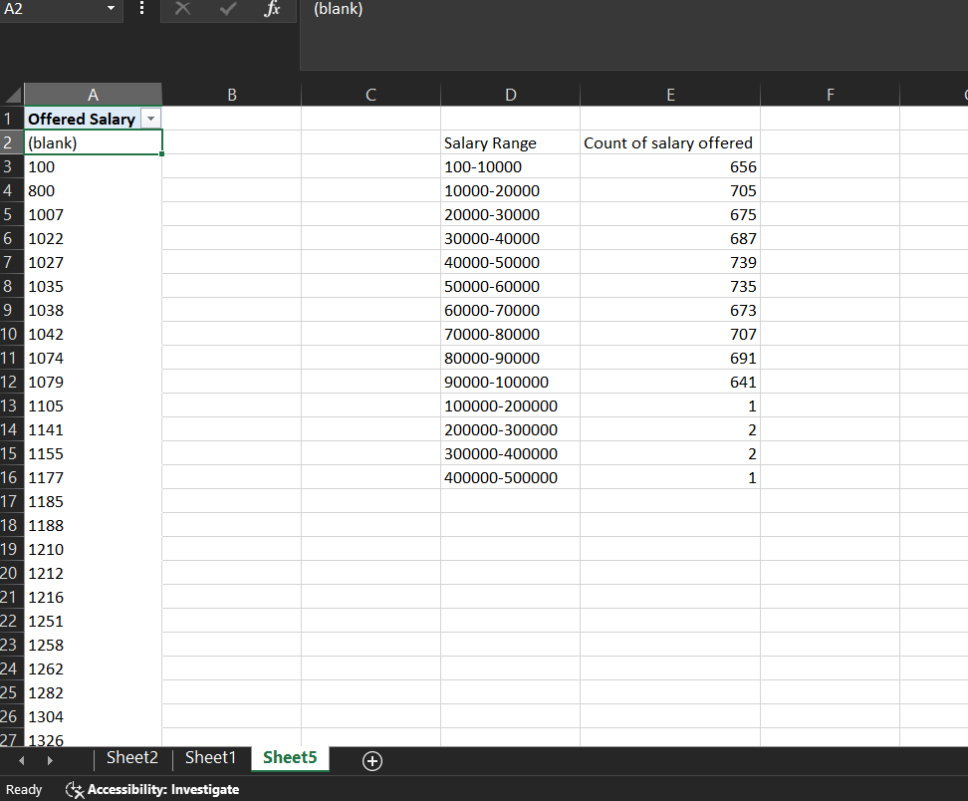

**Here, I made a pivot Table after finding the minimum and maximum salary using the MIN and Max formula. In the Pivot Table, I manually made class intervals and used the COUNTIF formula. Through this, I found out that a huge chunk of people lies in the range of 40,000-50,000. Whereas, the least number of people fall above the salary range of 1,00,000.**

**Task D: Department Analysis**

**Visualising data through charts and plots is a crucial part of data analysis. Using a pie chart, bar graph, or any other suitable visualisation to show the proportion of people working in different departments.**

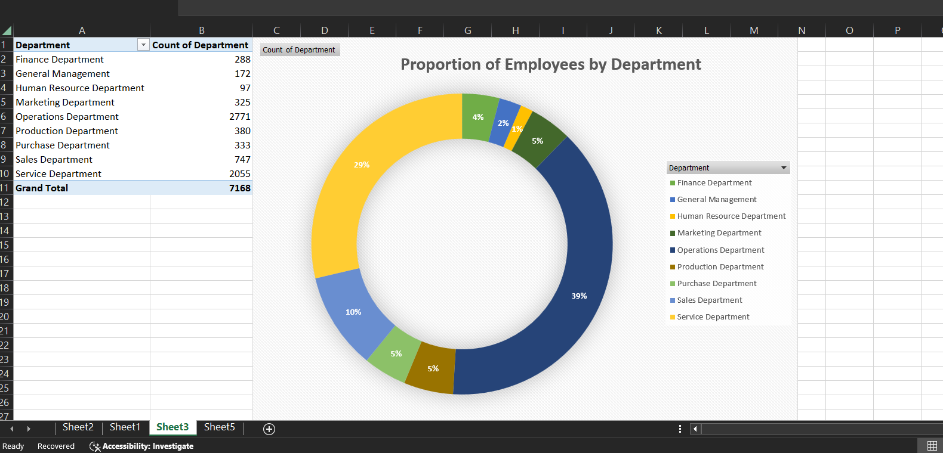

**After creating the Pivot Table, I surfed through the insert option and selected the pie chart and bar graph. Thereafter, I adjusted the title, and added data labels to show the count for better readability**

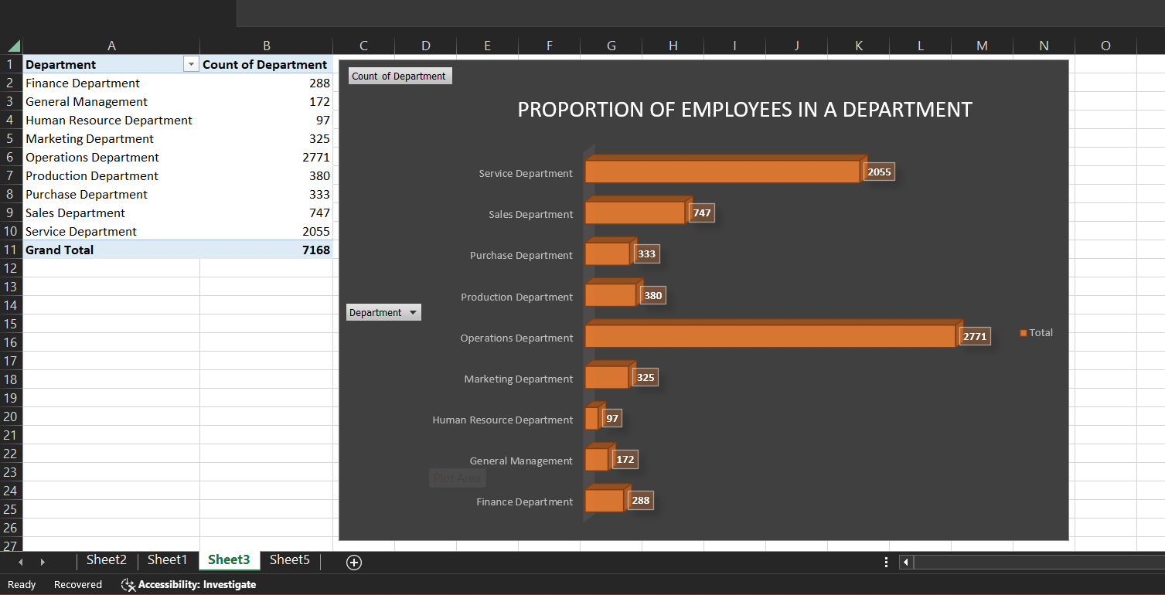

**From this analysis, it is found that majority of people work in the operations and services department whereas, the Human Resource Department has the least number of people working.**

**Task E: Position Tier Analysis**

**Different positions within a company often have different tiers or levels. By using a chart or graph to represent the different position tiers within the company. This helped in understanding the distribution of positions across different tiers.**

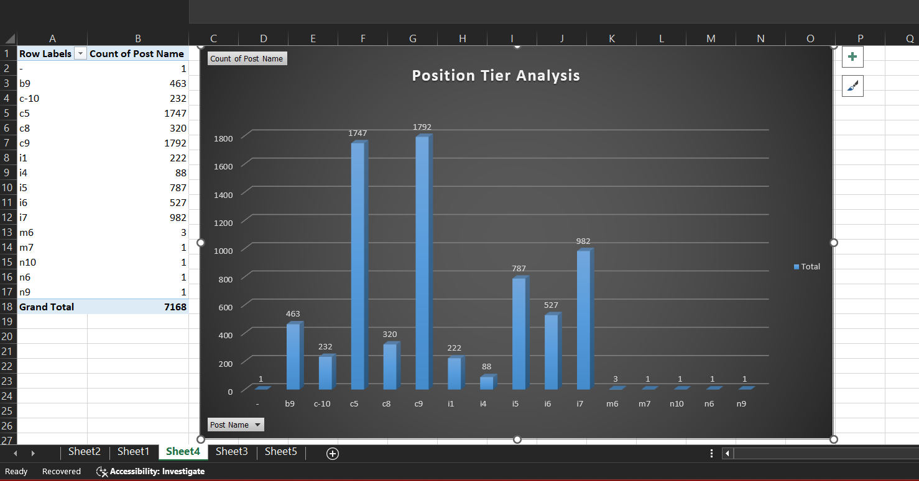

**After creating the Pivot Table, I surfed through the insert option and selected the bar graph. Thereafter, I adjusted the title, and added data labels to show the count for better readability. It is evident that most of the people are working in c9, c5, and i7 respectively. The least number of employees work in m6,m7,n10,n6,n9.**

**Results:**

**Achievements:**

**1. Analytical Skills:**

**- Improved ability to handle real-world datasets and derive insights using Excel.**

**2. Understanding Hiring Metrics:**

**- Gained insight into tracking key metrics like gender distribution, salary averages, and position tiers.**

**3. Diversity and Inclusion:**

**- Analysed gender distribution to understand the company's diversity efforts.**

**4. Compensation Analysis:**

**- Provided insights into salary strategies and identified areas for improvement.**

**5. Visualization Skills:**

**- Enhanced ability to create visual data representations for better decision-making.**

**6. Strategic Recommendations:**

**- Made data-driven suggestions to improve the hiring process, focusing on diversity and competitive salaries.**

**Overall, this project deepened my understanding of hiring process analytics, equipped me with essential analytical skills, and enabled me to provide actionable insights for improving recruitment strategies.**

**Excel Worksheet Link:**

**https://1drv.ms/x/c/c06641675a449bb4/ETpSqfv_wjNBpWp2Ld7whBYBPChEA3JH98jyfSUfBqlb-g**